| Experiment No. 8 |
| --- |
| Program to demonstrate CRUD (create, read, update and delete) operations on database (SQLite/ MySQL) using python |
| Date of Performance: |
| Date of Submission: |

**Experiment No. 8**

**Title:** Program to demonstrate CRUD (create, read, update and delete) operations on database (SQLite/ MySQL) using python

**Aim:** To study and implement CRUD (create, read, update and delete) operations on database (SQLite/ MySQL) using python

**Objective:** To introduce database connectivity with python

**Theory:**

In general CRUD means performing Create, Retrieve, Update and Delete operations on a table in a database. Let’s discuss what actually CRUD means,

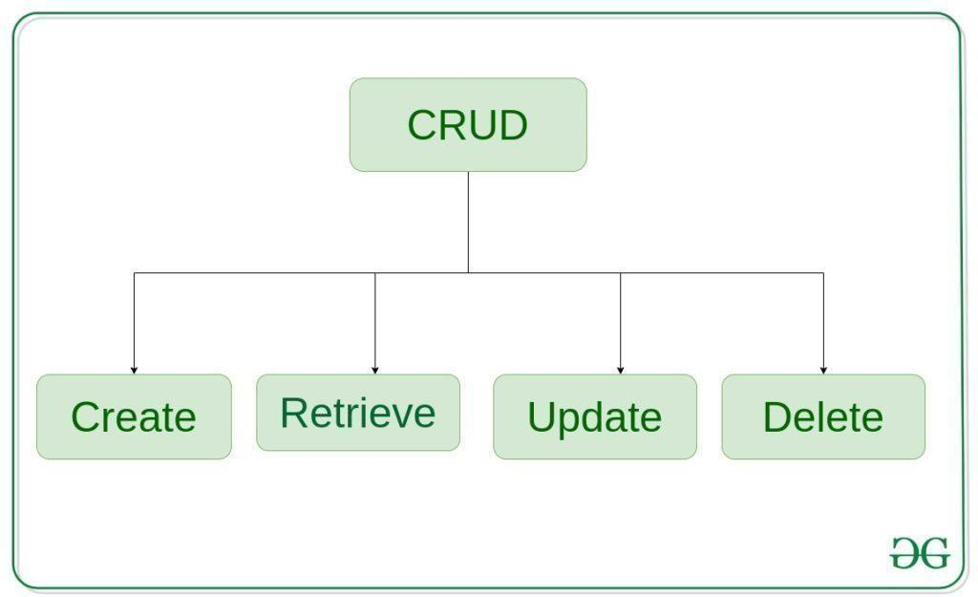

**Create** – create or add new entries in a table in the database.

**Retrieve** – read, retrieve, search, or view existing entries as a list(List View) or retrieve a particular entry in detail (Detail View)

**Update** – update or edit existing entries in a table in the database

**Delete** – delete, deactivate, or remove existing entries in a table in the database

**Code -**

import sqlite3

conn = sqlite3.connect('example.db')

cursor = conn.cursor()

cursor.execute('''

CREATE TABLE IF NOT EXISTS users (

id INTEGER PRIMARY KEY,

name TEXT NOT NULL,

age INTEGER

)

''')

conn.commit()

def create_user(name, age):

cursor.execute('INSERT INTO users (name, age) VALUES (?, ?)', (name, age))

conn.commit()

def read_users():

cursor.execute('SELECT * FROM users')

users = cursor.fetchall()

for user in users:

print(f"ID: {user[0]}, Name: {user[1]}, Age: {user[2]}")

def update_user_age(user_id, new_age):

cursor.execute('UPDATE users SET age = ? WHERE id = ?', (new_age, user_id))

conn.commit()

def delete_user(user_id):

cursor.execute('DELETE FROM users WHERE id = ?', (user_id,))

conn.commit()

create_user('John', 27)

create_user('Emma', 35)

print("All users:")

read_users()

update_user_age(1, 28)

print("All users after the update:")

read_users()

delete_user(2)

print("All users after the deletion:")

read_users()

conn.close()

**Output -**



**Conclusion:** CRUD operations has been studied and implemented.